StSS

**Staff Nurse**

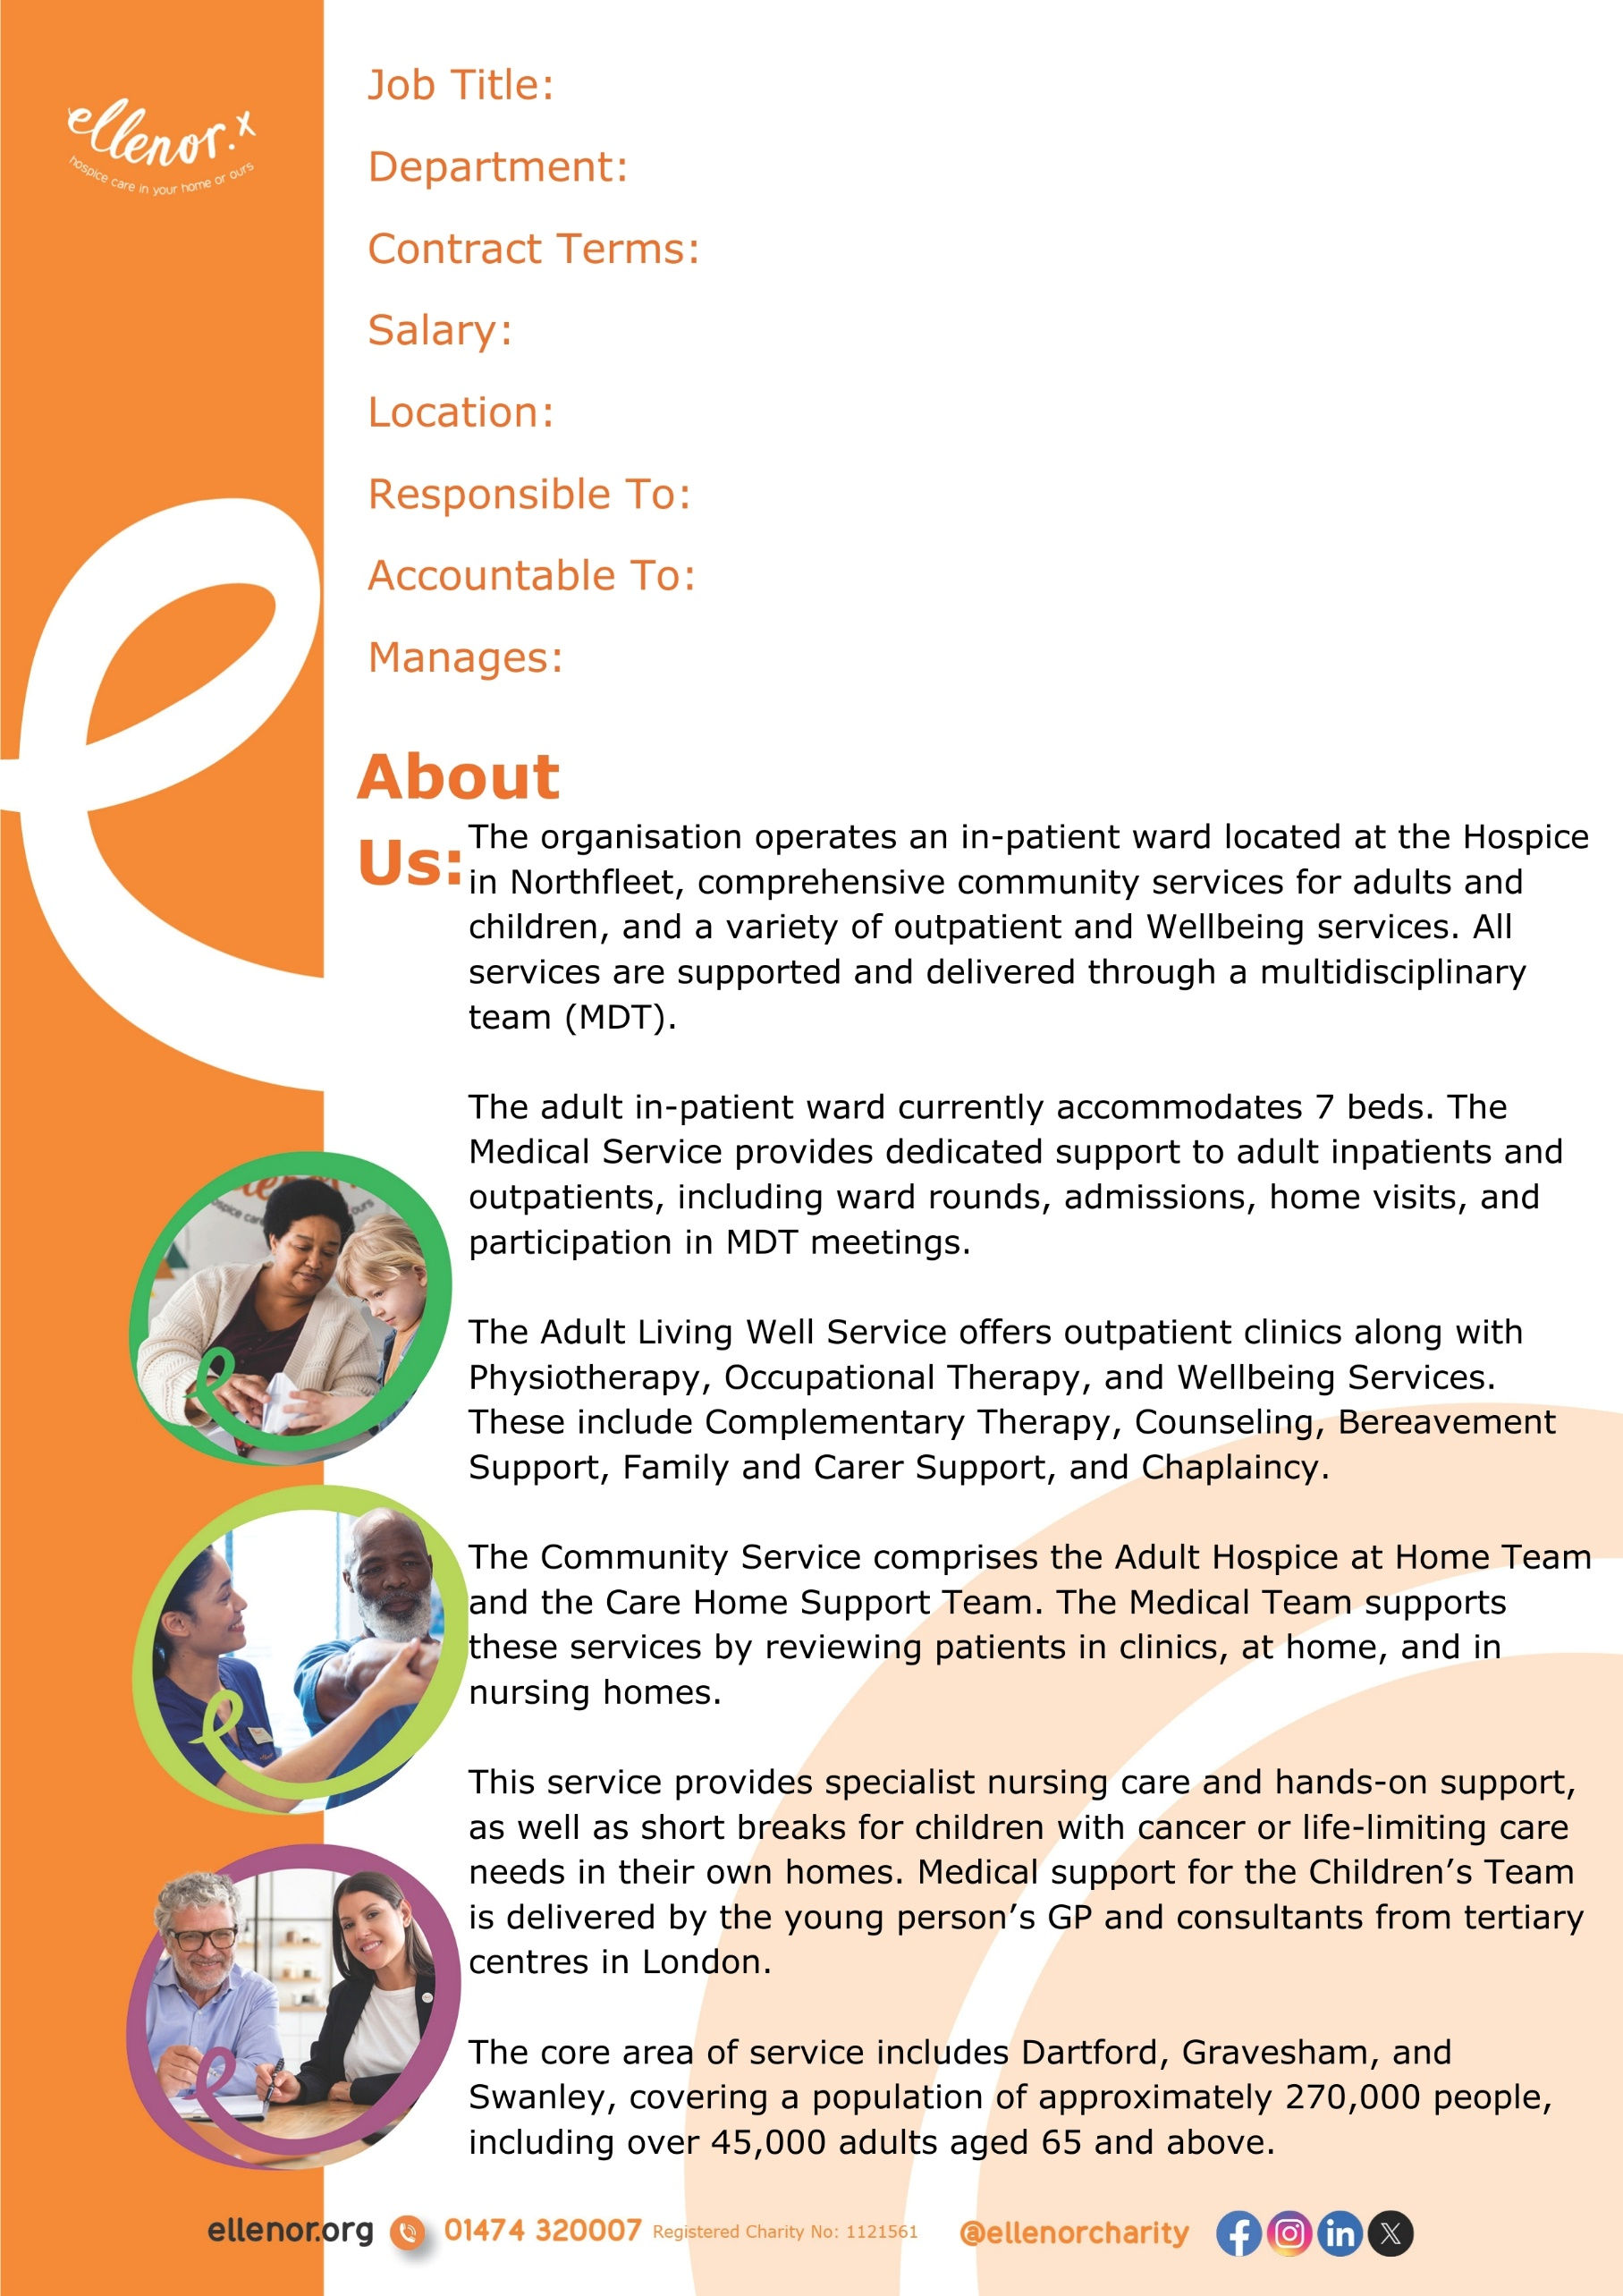

23 hours per week

Inpatient Ward

Staff Nurse

£31,331 - £35,617 dependant on experience

dedependant on experience

Operational Lead for Inpatients

Northfleet, Kent

Director of Care

N/A

The In-patient ward is currently seeking a registered nurse with a clinical background in palliative/cancer care, or a registered nurse who is looking to develop a career in palliative/cancer care. Preferably with post-registration experience.

You will be responsible for ensuring:

* The highest possible standard of holistic care for patients with support for their families and those closest to them.
* Participate in the assessment of care needs, development, implementation and evaluation of programmes of care.
* Carry out relevant forms of care without direct supervision.
* Supervise and direct non-registered nursing staff; and volunteer assistants.
* To triage out-of-hours calls, giving advice if appropriate or referring to an on-call Senior Nurse or Doctor as necessary.
* Encouraging family participation in the care of the patient and, where appropriate, respecting individual and cultural choices as well as the patient’s wishes.
* All care is documented clearly in the electronic patient records (training will be given) and completed in line with mandatory legal requirements, in particular that it is accurate and up to date.
* You will work as part of an integrated team of nurses contributing to overall care and providing practical nursing interventions.
* Work within **ellenor** mission & philosophy at all times and base care on evidence-based practice.
* Liaise with all internal & external colleagues to ensure smooth communication of patient information.
* Work in partnership with the Primary Health & Social care professionals and the Hospice multi-professional team, in meeting the patient's palliative care needs.



**Clinical Practice**

* Work within **ellenor’s** mission and philosophy at all times and base care on evidence-based practice.
* Work within the local operating procedures for the appropriate area.
* Use a systematic process of assessment of care needs, involving the patient and family in planning the agreed care as far as possible.
* Maintain patient dignity and privacy at all times, especially during the implementation of care planned.
* Ensure accurate evaluation of care and treatment provided with timely reporting of outcomes to the Medical and Nursing teams.
* To work effectively as part of a team to ensure the highest standards of care and quality are delivered and maintained.
* Ensure all care is documented clearly in the electronic patient notes and completed in line with mandatory legal requirements, in particular, that it is accurate and contemporaneous.
* Undertake all paper documentation such as joint assessments in a timely manner, ensuring it is accurate, relevant and contemporaneous.
* Ensure that patient consent is given prior to any treatment or care, including photography.
* Encourage family participation in the care of the patient where appropriate respecting individual and cultural choices as well as patient’s wishes.
* Take an active role in preparation and participation in the weekly MDT patient review meetings.
* Actively promote patients' preferred “place of care” choices and work towards home discharge in a timely and effective way.
* Support the palliative care needs of patients in the community by working with the Hospice at Home team providing telephone advice out of hours, reassurance as appropriate and passing calls on to the Clinical Nurse Specialist as appropriate.
* Liaise with all internal and external colleagues to ensure smooth communication of patient information.
* To establish a therapeutic relationship with patients and relatives to enable active involvement in informed decision-making, if this is their wish.
* To use communication skills during assessment, implementation and evaluation of all aspects of patient care and treatment.

* To liaise with appropriate staff to facilitate effective hospice admission and discharge planning.
* To offer bereavement support to carers as per the hospice-agreed pathway.

**Professional Development, Education and Training**

* To liaise and communicate with the community, nursing home and hospital staff in order to raise awareness and promote Hospice services.
* To liaise and work in partnership with the Primary Health and Social care professionals and the hospice multi-professional team, in meeting the patient’s palliative care needs.
* To undertake any other duties considered to fall within the scope of the position of Staff Nurse, as directed by the Team Leader.
* To work safely, in line with lone working and other related policies.
* Ensure that risk assessments are updated in a timely manner.
* Act as patient advocate in line with NMC guidance.

**Audit & Quality**

* To be aware of new developments in palliative care.
* To participate in nursing and interdisciplinary audit projects.
* To participate in the hospice Clinical Governance programme.

**Professional Conduct**

Every Registered Nurse is responsible for their actions and practice, ensuring accountability to patients and their loved ones for the care they provide. They must adhere to the professional code of conduct established by the NMC.

**Health and Safety**

The post holder has the responsibility to take reasonable care of self and others in relation to managing risk, health and safety and will be required to work within the appropriate policies and procedures.

##### **GENERAL**

* To be aware of the philosophy of **ellenor** and to behave as a fit representative.
* To abide by **ellenor’s** general confidentiality policy.
* To keep abreast of and work in accordance with hospice policies as outlined in the staff handbook, the Library or the policy folders held in each department.
* To undertake bi-annual performance review when a personal development plan will be discussed.
* To attend statutory and specialised training when required.
* At **ellenor** we are committed to creating and managing a safe working environment for all our staff, visitors, volunteers and patients. All **ellenor** employees are expected to know, understand and deliver their Safety Responsibilities. All **ellenor** employees may be set at least one Safety Objective by their manager or supervisor which must be delivered if they are to meet their objectives.



* Good understanding of the role and the role that specialist palliative care has in end-of-life care.
* Ability to work flexibly and effectively with patients, families and colleagues.
* Resilient and able to meet the complex demands of the post, taking on unscheduled tasks and working well under pressure.
* Ability to work autonomously with an unpredictable work pattern, managing time, commitments and priorities.
* Knowledge of symptom management, and the ability to assess patients psychologically. Social & spiritual needs.
* To be able to utilise IT equipment as required for this role.
* First Level Registered nurse with post-registration experience, preferably in a relevant field of nursing.
* Diploma or degree qualification in Nursing (Desirable).
* Have evidence of recent continuing professional development.
* Have a flexible approach to working hours, and days of the week and be able to work night duty on a rotational basis.
* Be willing to undertake further study /attend in-house training.
* A teaching, mentor/supervisor module (Desirable).

**Knowledge, Skills and Attributes:**

* Experience working in palliative care, end of life or oncology.
* Experience of working in a hospice setting (Desirable).
* Experience working within one's evolving level of competence while recognising and understanding personal limitations.
* Sufficient knowledge of palliative and end of life care assessment tools /outcome measures and improvements they bring to patient care.
* Knowledge of symptom management, and ability to assess patients psychological, social & spiritual needs.
* Ability to communicate effectively at an advanced level with patients and families.

**Experience:**